Readme

The Virtual Scene is a Bedroom, consisting of a Bed, a Study Table, a Study Chair, a Study Lamp, Coffee Mug, Laptop, Printer, a ceiling fan, a Clock, some paintings, a Cabinet.

The 3D travel technique I have tried to implement uses the comparison of absolute values of x, and y to determine to either go forward or backward or go sideways left or right.

The following are used,

When button is pressed &

If |x| > |y| & x < 0, we steer towards left

If |x| > |y| & x > 0, we steer towards right

If |x| < |y| & y > 0, we steer forward

If |x| < |y| & y < 0, we steer backward

And if !buttonPressed, we don’t Steer

Figure 1: The following figure consists of the five states used in the 3D Travel Technique, and the inputs they take

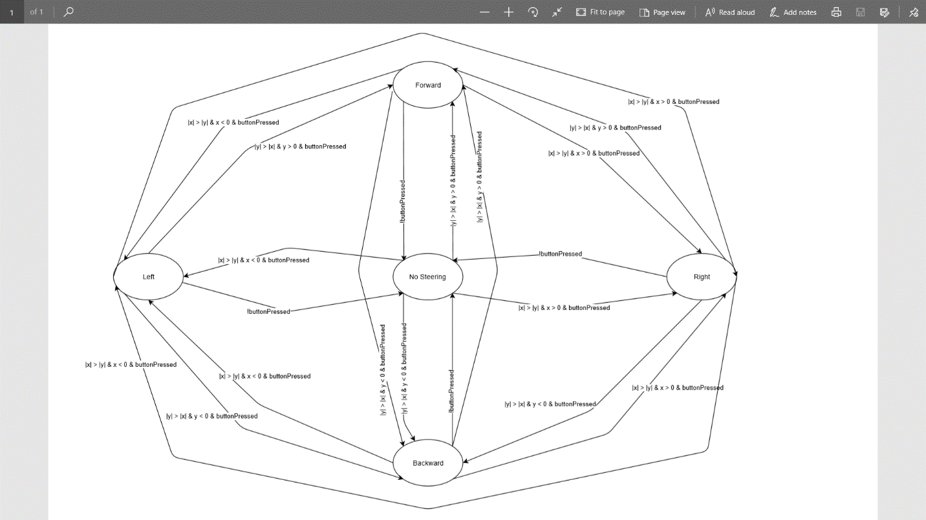

The following objects in the scene consists of 3D sounds:

Ceiling fan (on loop)

Clock (on loop)

Air Vent (AC/Heater) (on loop)

Laptop fan (on loop)

Printer (Starts with a delay of 3s, and plays once)

Please navigate to:

~\3D Virtual Environment\Assets\Scenes\SampleScene.unity

And open the SampleScene.unity file in unity.